Dog and Cat essentials and toys mood board

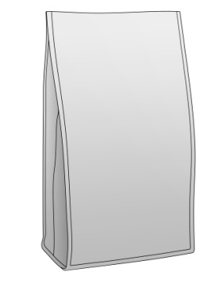

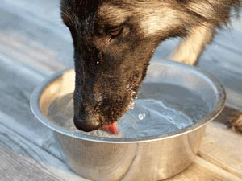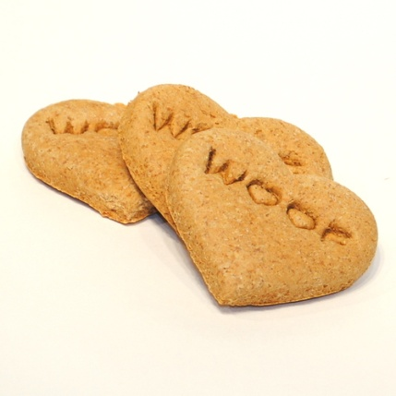

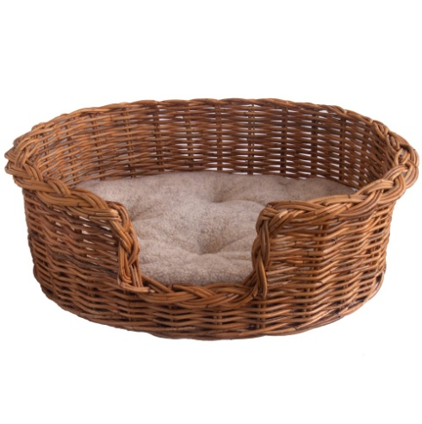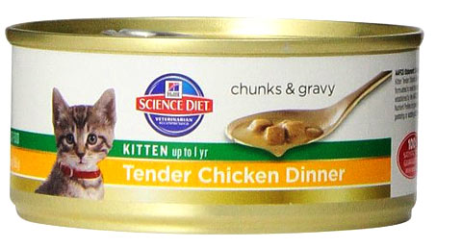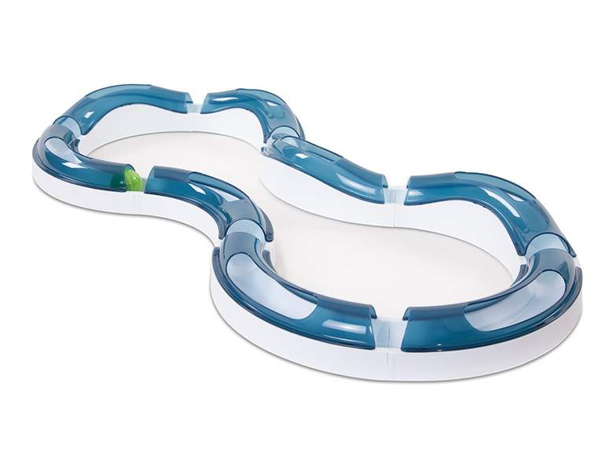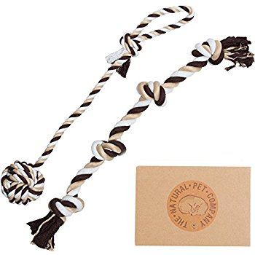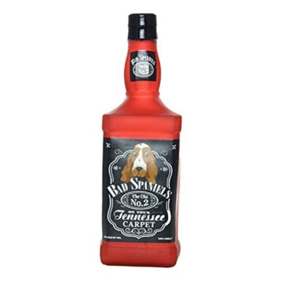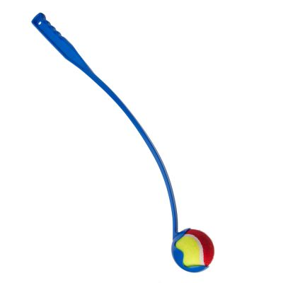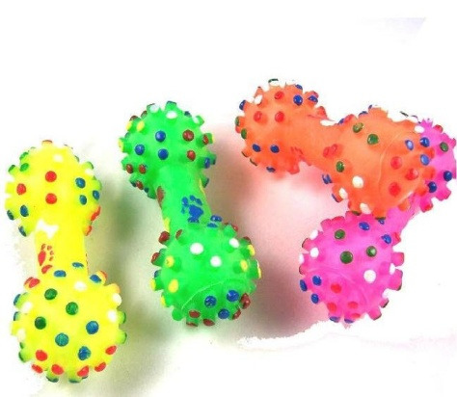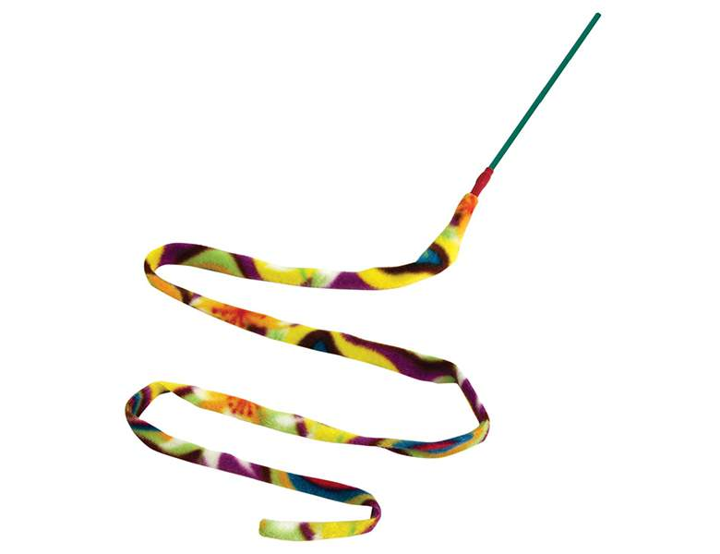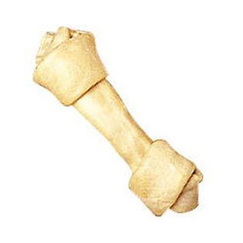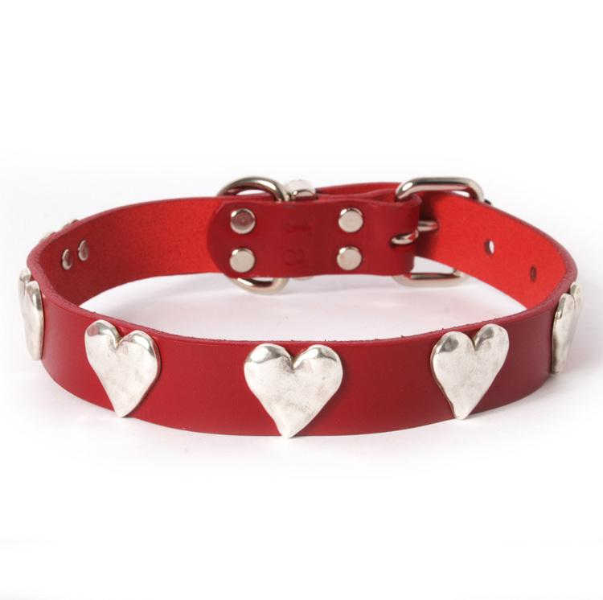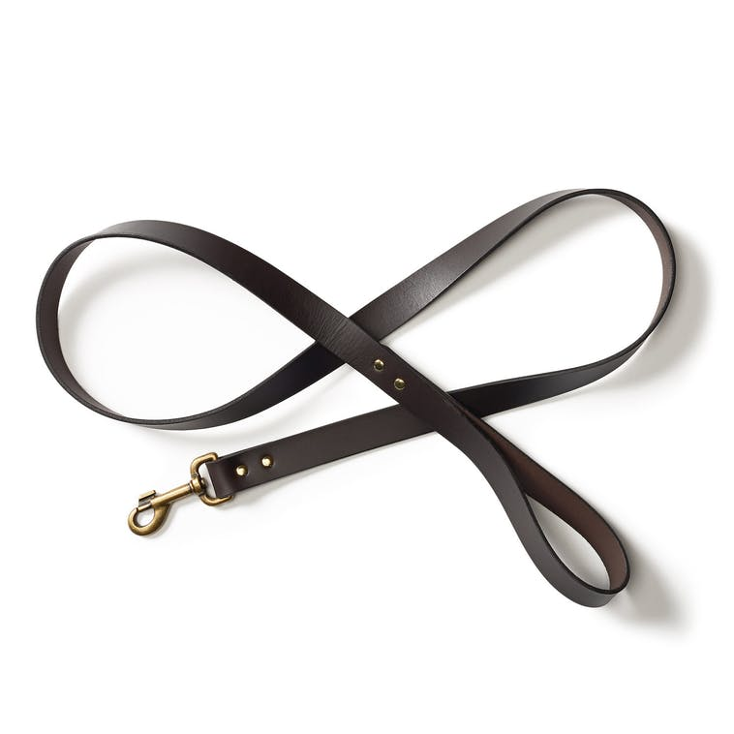

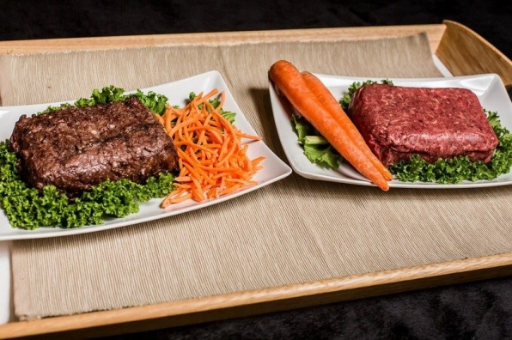

References

Designermixes.org. (2011). *Providing Water for Your Dog*. [online] Available at: <https://www.designermixes.org/dog_articles/14/providing_water_for_your_dog.aspx> [Accessed 21 Nov. 2017].

Fetch.co.uk. (2017). *Silly Squeaker Liquor Bottle Bad Spaniels*. [online] Available at: <https://fetch.co.uk/silly-squeaker-liquor-bottle-bad-spaniels-376208011>[Accessed 21 Nov. 2017].

Guha, G. (2013). *Dog Chew Bone*. [online] www.indiamart.com. Available at: <https://www.indiamart.com/proddetail/dog-chew-bone-6573914348.html> [Accessed 21 Nov. 2017].

Kosmopolitan. (2017). *Classic Wicker Dog Basket + Fleece Cushion - Kosmopolitan*. [online] Available at: <https://www.kosmopolitan.co.uk/product/classic-wicker-dog-basket-with-fleece-cushion-5-sizes/> [Accessed 21 Nov. 2017].

Mangham, J. (2014). *17 Essentials For New Pup Parents To Keep Your Dog Smiling*. [online] BarkPost. Available at: <https://stories.barkpost.com/new-dog-essentials/> [Accessed 21 Nov. 2017].

Media, P. (2016). *Pet Food Packaging Supplier | Law Print & Packaging*. [online] Law Print & Packaging Management. Available at: <http://lawprintpack.co.uk/pet-food-packaging/> [Accessed 21 Nov. 2017].

Pet Company, T. (2017). *Two Fantastic Quality Dog Toys in Beautiful Gift Box by The Natural Pet Company (Tug-of-War Dog Rope Toy Double Pack) (For Interactive Play With Your Dog)*. [online] Amazon.com. Available at: <https://www.amazon.com/Fantastic-Natural-Pet-Company-Interactive/dp/B00UHUZGHA> [Accessed 21 Nov. 2017].

Smith, A. (2016). *Top 10 Healthiest Homemade Dog Food Recipes*. [online] DogsAholic. Available at: <http://dogsaholic.com/food_treats/homemade-dog-food-recipes.html> [Accessed 21 Nov. 2017].

Supplies, C. (2017). *12 Essential Kitten Supplies Every Pet Owner Needs*. [online] Band of Cats. Available at: <http://www.bandofcats.com/essential-kitten-supplies/> [Accessed 21 Nov. 2017].

Tompkins, R. (2015). *Top 15 Best Interactive Cat Toys 2017*. [online] Heavy.com. Available at: <http://heavy.com/pets/2015/11/top-best-interactive-cat-toys/> [Accessed 21 Nov. 2017].

Zooplus.co.uk. (2017). *Dog Toys: Tennis Ball Launcher. Free P&P on orders of £29+ at zooplus*. [online] Available at: <http://www.zooplus.co.uk/shop/dogs/dog_toys_dog_training/flying_dog_toys/more_toys/282152> [Accessed 21 Nov. 2017].